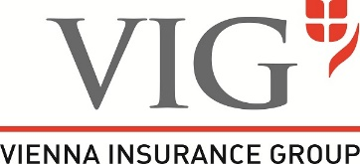
Question form

for the 31st Annual General Meeting of
VIENNA INSURANCE GROUP AG Wiener Versicherung Gruppe held in Vienna
on 20 May 2022, at 11 a.m. (CEST) as a virtual Annual General Meeting

IMPORTANT NOTE: This form does not authorise shareholders to attend the Annual General Meeting in person.
Please contact your bank maintaining your securities account and make sure that your shares have been duly registered to participate in the Annual General Meeting by deposit receipt (record date: 10 May 2022, midnight [CEST]).
Deadline for registration: 17 May 2022 (Receipt of deposit receipts)

Shareholder submitting a question

First name, last name / company name
Street address, postal code, city/town Date of birth / register no.
Securities account number Bank
E-mail address

Dear shareholders,

You are kindly requested to e-mail your questions in advance to fragen.vig@hauptversammlung.at in due time so that they are received by the Company by 18 May 2022 at the latest. This will enable the Managing Board to prepare as thoroughly as possible and to respond to your questions expeditiously at the Annual General Meeting.

During the Annual General Meeting you may only send (additional) questions exclusively in text form by e-mail directly to the Company’s e-mail address fragen.vig@hauptversammlung.at. For further details please see the information on the organisational and technical requirements for participation pursuant to Section 3 (3) in conjunction with Section 2 (4) COVID-19-GesV (“information on participation”), which is available at the Company’s website www.vig.com/annual-general-meeting.

Agenda item | Questions

Date | Signature / duly authorised company signature | Signatures of all co-owners, if applicable

